February 2023 DCC Monthly Report

Cllr Sara Randall Johnson

DCC Budget setting 2023/24

Unlike other Government and quasi-Governmental organisations, such as the NHS, Devon County Council is required like all local Government organisations is required by law to produce a balanced budget each year and the process for 2023/24 is nearly complete, having progressed through most of the checks and balances, scrutiny and consultations it must do before reaching Full Council, to seek approval on the 16th of February 2023.

In normal times this is a monumental task trying to balance the books with many competing interest for the limited resources available, but we do not currently live in what might have previously been regarded as normal times. This time last year having got through the worst ravages of the Covid 19 pandemic it would have been hard for the majority of us to predict the horrifying situation in Ukraine, and the impact of it on our economy and cost of living, making life much harder for very many people.

DCC puts great focus on helping those who need help most, including young people and vulnerable adults, with this reflected in the table below for 2023/24.

Items like Public Health and funding for schools are ‘ring fenced’ i.e. must be spent on these items and so the amount that DCC can use as its day to day running or revenue expenses is nearly £630 million in 2022/23 and a proposed £696 million in 2023/24, a 10.5% increase.

The overwhelming amount of this is invested in to Adult and Children’s services, who are both set to get large increases of 8.8% and 18.4% respectively, largely driven by soaring demand and the cost of providing services, many of which are mandatory for DCC to provide

The figures are staggering and there is still never enough in the pot, where DCC is constantly looking at ways to work more efficiently and effectively for the people of Devon, getting a share fairer share from Westminster.

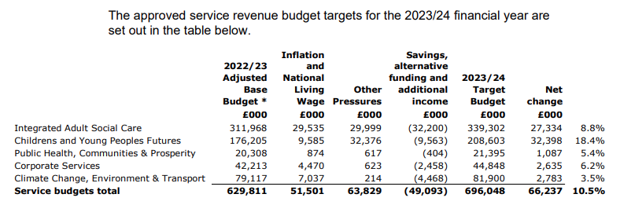

Highways

As we go about our daily business it is apparent that our Highways are taking a severe battering this winter, with safety defects, largely pot holes being reported at an alarming rate over the the longest roads network in England, where DCC is responsible for over 12,800 kilometres (8,000 miles), a huge task a the best of time with limited resources.

Over and above the proposed Highways budget for 2023/24 it has been agreed to put a further £1m in to Highways drainage for 2023/24 , as I’m sure many of the reasons for so many potholes this winter is down to water on the roads. In the overall scheme of things the total amount of money to fix potholes and get our entire road network in England to a safe and acceptable standard is quite small at approximately £14bn pre this winters ‘rainy season’.

The problem with constantly fixing potholes is you never get ahead of the game with planned maintenance, in order to reduce them or deliver planned upgrades where money is better spent on long lasting solutions. As you might imagine DCC are constantly lobbying for increased funding on a permanent and ad hoc basis, in order to improve matters.

Just a reminder that if you want to report a problem, including Highways defects, faulty street lighting, flooding and blocked drains etc please visit <https://www.devon.gov.uk/roadsandtransport/report-a-problem/>

# Want to hold a Coronation street party?

Finally something to and celebrate!

DCC are inviting communities across Devon, (who prefer something local to them), to apply for a free street party licence to mark the coronation of His Majesty King Charles III and Her Majesty, The Queen Consort.

The Coronation takes place on the morning of Saturday 6 May at Westminster Abbey, and on Sunday 7th May Coronation Big Lunches will bring communities together with a special Coronation Concert at Windsor Castle.

Throughout the weekend of festivities hundreds of events, ranging from traditional street parties and lunches to Jubilee markets, fun-days, and galas, are expected with many taking place on Devon streets.

If your community wants to hold a street party DCC are asking that you apply using the online basic street party application to close off your street available at <https://tinyurl.com/ymxf5we9> you can do this for free and applications can be made for Saturday 6th Sunday 7th or Monday 8th May.

This form is for minor residential roads and cul-de-sacs only and they will be considered on an individual basis.

If you want to apply for a street closure on a busier road applications can still be submitted by making a Special Event application at <https://tinyurl.com/38cfvsrn> However, these usually require three month’s notice, and they will only be approved if it’s practical. The application may incur a fee**.**

DCC expects a huge number of applications, approximately 160 street closures were granted ahead of the Queen’s Platinum Jubilee celebrations last year, and if you are thinking of applying please do so ahead of the cut-off date of Sunday March 26th

ENDS