Present: Cllr D. Mitchem (DM), Cllr B. Thrussell (B.T), Cllr C.Edwards (CE) Cllr S.Walton (SW), Cllr.C. Jones

1. Apologies – Cllr S. Randall Johnson DCC, Cllr Paula Fernley EDDC
2. Risk Assessment.-No Risks
3. Declarations of Interest/requests for dispensation-None
4. Minutes from November 2023 Parish Council Meeting: Accepted and approved.
5. Open Session 5 Bells: **DM** asked if there was any news on what was happening with the 5 Bells which is currently closed. Amy Durkin informed us that the property owners are actively seeking someone to take on the lease and very much want to see it continue as a public house. But so far no suitable applicants.
6. County/District Councilors Reports. Attached at end of minutes. Please note that DCC report indicates the major financial constraints it is facing with 80% of the budget being required for its legal obligation to support children and the elderly.
7. Local Issues.

i**)CJ** Brought up about vandalism in the playground. A complaint was to him about a n attempt to set fire to the swings and deliberate littering of the area. (Action to send letter to EDDC about the vandalism as they are responsible for the playground). Discussion with the floor about upgrading the area and **DM** suggested if a petition was raised by Parishioners to upgrade the playground the PC would support it.

ii)Sue Williams drew CJ's attention to the the growing pot holes outside her home, 'Chelveshayes', which are greatly aggravated by the daily traffic of heavy farm machinery from 'Twynhayes' at the end of School Lane the back of the church: **CJ** had been contacted re large pot holes at the back of the church. He had contacted Highways and been told there it was not sufficiently serious for them to undertake the woek and could the PC undertake the repair with their own tarmac.. Can the Parish council do anything? Suggested taking photo of the pot holes and putting on the DCC website.Also suggested a subn=mission in the Clyst Hydon News explaining bhow the public can report on line pothole issues and repairs. Agreed

iii)**CJ** what to do about a footpath sign that has broken and fallen over. **CJ** to notify the EDDC footpath warden.

iv) **CJ** Started discussion about maintaining momentum on reducing speed limit outside school to 20mph. At a previous meeting **Cllr Gent** had given contact details of who to write to at DCC. **CJ** had written in November but had no response.

Discussion about extending beyond the school. It was agreed to do one step at a time and **CJ** to ask **Cllr Gent** how to proceed.

v)Solar Farm CE asked when it was starting as due to start this spring. No one had any information. After long discussion it was agreed **CE** would contact Lightrock/Bluefield to try and obtain information.

vi) Difibrilator: CJ Asked about the batteries for the difib. CE had contacted the British Heart Foundation and they cost £74. Discussion on how to change the batteries and how to check if they needed changing as the defib is passing all monthly checks.Agreed to contact BHF again to seek advice.

1. Highways. Drainage outside Farranthayes completed and appears to be working well.
2. Planning

23/23524/ful. No objections

1. Finance: Current balance in account £7651.57. Current annual expenditure slightly over current precept. Precept to be held for this year , but may need to rise next year.
2. Correspondence- None

The meeting ended at 8:00pm

Next Meeting March 4th 2024

Minutes accepted as true and accurate

Signature 1 Chairman………………………………….

Signature 2 Cllr…………………………………………

Date……../…….../……

**Actions**

|  |  |  |
| --- | --- | --- |
| Action | Person | Outcome/Closure |
| Write letter to EDDC re vandalism in playground | CJ |  |
| Send photo of pothole to DCC | CJ |  |
| Put article in CHN advising how to report potholes | CJ |  |
| Notify EDDC about broken Footpath sign | CJ |  |
| Contact Cllr Gent re progressing 20mph outside school | CJ |  |
| Contact Lightrock/Bluefield power re Solar Farm | CE |  |
| Contact BHF re battery checks/replacement on Defibrillator | CE |  |
|  |  |  |
|  |  |  |

**January 2024 – DCC Monthly Report**

**Cllr Sara Randall Johnson**

Happy New Year as DCC ramps back up to full speed after the Christmas Holiday break, which I hope, will be a prosperous and healthy one for all of you, your families and friends. This month’s Division members report focuses on the finances of Devon County Council ahead of target setting for the various service areas of the Council ahead of next month’s Budget setting for 2024/24 in what is going to be an interesting year for everyone in Local and National Government.

Budget 2024/2025

Setting the DCC Budget for 2025/25 is like any year, a huge task for a large scale organisation. Over 79% of the nett revenue budget of £743.4million proposed for 2025/25 is spent on children’s and adult service areas i.e. £588.5m with £154.8m for the others

Demand in these two areas in particular continues to surge, where DCC must legally provide them, often at very high costs, over and above ahead of what is termed called discretionary services such as routine roads maintenance (other than safety issues) of a 12,000 mile road network, bus service subsidies, climate change initiatives and much more.

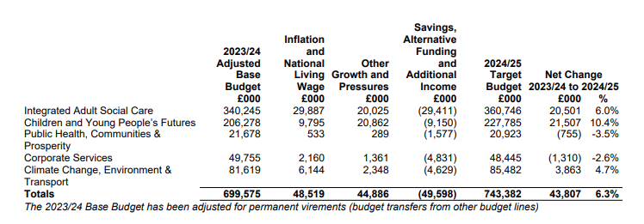

The funding for this comes from a wide range of Core funding income from the Government and Other Grants totalling around £236.4m, but the majority of the income is derived from Council tax and a share of Business rates.

This is set against set against a background inflationary cost of living pressures and huge challenges to Local Government in general. Social care provision is particularly impacted by increases to the national living wage, which at first glance a 30p per hour increase announced by the Government does not seem vast. However, it will add an extra £25.7m to the DCC wage bill, which will need to come from further savings and efficiencies.

There is an above inflation proposed 10.4 per cent increase in the revenue budget for children's services with a 6 per cent rise in adult services and 4.7 per cent extra for climate change, environment and transport.

Reductions in other departmental spending means an overall rise of 6.3 per cent in the council's budget for next year within the total spend of over £743 million where Officers of the Council have worked closely with the DCC Cabinet to secure best value across Devon's operations and ensure continuing financial sustainability.

To set a balanced budget, savings, alternative funding and additional income of £49.6 million have been identified. Overall, there is additional funding of £43.8 million or 6.3% for services next year. It is not planned to support the proposed budget targets by using general reserve balances. This reflects a strategy of DCC ‘living within its and to set service budgets that are affordable within anticipated income and funding totals for next year.

ENDS

